Neste Oyj Sell

We recommend **Sell** based on our valuation and analysis. The fair stock price suggested is slightly lower than the current stock price. The devasting impact brought by COVID-19 on the energy industry is not negligent, despite the past expansion and great performance that Neste has shown to its investors.

Recommendation: Sell

|  |  |
| --- | --- |
| Target price | 37.5 |
| Fair value |  |
| Share price | 46.39 |
| Downside | -19% |
| Key figures | |
| Symbol | NESTE.HE |
| Annual dividend in 2020(EUR) | 0.8 |
| Yield | 1.70 |
| 52 weeks range | 22.63-64.74 |
| Avg. Volume | 1181739 |
| Revenue 2020(MEUR) | 11751 |
| Market Cap(EURbn) | 35.628 |
| Beta | 0.74 |
| P/E ration | 50.78 |
|  |  |

Share price development

Revenue 2020 by divisions

Key data

Neste Oyj, a global leading energy and chemical company. Neste is listed in Helsinki stock exchange. Founded as an energy company, Neste now aims at accelerating a shift to circular economy and combating the climate change by providing sustainable products and services.

We issue a sell recommendation on Neste with a target price of EUR 37.5, presenting a 19% downside potential on the closing price of EUR 46.35, on 1st, April 2020. Our valuation is based 50% on Discounted Free Cash Flow and 50% on Discounted Dividends. Our DCF analysis values the equity of the company at EUR 39.02, implying that the company is overvalued by 16%. Analysis from DDM analysis indicates a price at 36.1, representing a downside of 22%. In fact, most investors may notice the fact that the current market price is overpriced. Consequently, the market price has been continuously adjusted from over 60 EUR in Jan 2021. Overall, we believe the public is generally overconfident with the future development, leading to overpriced.

**The public is generally too optimistic about the financial position and profit-operating performance**: Neste has maintained its financial target since 2015(ROCAE above 15%, leverage below 40%) indicates that the company has a healthy and profitable business model. The solid liquidity in the past makes investors confident in the future development. Yet, given the fact that there are many ongoing projects announced and M&A in the past, we think the public is longing to past great performance.

**Ongoing pandemic threatens the growth of Neste**: We believe that the past performance is no longer to be replicated. The declining demand for oil products and renewable fuel products from the transportation sector have no doubt brought negative impacts on the future profits of Neste. Additionally, as the development and organization in the post-covid time remain uncertain for now, the company have pressure to generate profits with a satisfying growth rate and stabilize the cash flow.

***1.2. Current Highlights***

|  |  |  |  |  |
| --- | --- | --- | --- | --- |
| ***Key figures*** | ***2020*** | ***2019*** | ***2018*** | ***2017*** |
| EPS | 0.93 | 2.33 | 1.01 | 1.17 |
| P/E | 63.75 | 13.32 | 22.24 | 15.16 |
| P/BV | 7.66 | 4.02 | 3.74 | 3.15 |
| DPS | 0.8 | 1.02 | 0.76 | 0.57 |
| Dividend yield% | 1.4 | 3.3 | 3.4 | 3.2 |
| Leverage ratio | -4.7% | -3.3% | -1.5% | 15.4% |
| Share price Dec 31 | 59.16 | 31.02 | 22.45 | 17.78 |

**Key events in 2020**

* R&D related: Investment in developing Power-to-X solution.
* Investment in Recycling Technologies.
* Shut down the Naantali refinery operation to respond the declining demand for oil products.
* Acquisition of Mahoney in order to expand the global sustainable feedstock.
* Acquisition of a refinery plant in Rotterdam to increase the capacity of renewable production.

**Accelerating the group’s focus towards renewable and circular solutions despite ongoing pandemic**. Capacity expansion for renewable products of Neste proceeds well, despite the COVID-19 disturbances. New agreements and partnerships in the growing renewable products section have been announced by Neste, indicating the firm’s determination in terms of sustainable transition. 2020 is remarked by the growth in sales and production record of the renewable fuels and chemicals.

**Global expansion for feedstock and production platform.** The investment to expand the Singapore refinery helped increase Neste’s renewable product production capacity and enlarge the global feedstock of waste and residues. The two acquisitions completed in 2020 are also expected to grow Neste’s future raw material base.

**Innovation and technology play key roles in Neste’s growth.** 25% of the group’s personnel is contributed to innovative research. The innovation initiatives help to widen the supply of renewable waste and residue and develop recycling technologies. Meanwhile, Neste has an extensive collaboration network with 25 leading universities. The focus on innovation is highly possible to support the group’s growth in the renewable division.

Therefore, based on the above observation, we can predict a growing revenue in the renewable products sector.

*Table 1. Current and Future Revenue by Segments.*

***1.3. Investment summary***

*1.3.1. Significant recent and future developments*

During 2020, Neste updated its investment criteria to support the key actions on the roadmap of its climate action. This update made the Greenhouse Gas (GHG) impact of all investments visible (thanks to a mandatory evaluation of it) and set an internal price for GHG emissions. These new criteria will support prioritization of different investments needed to reduce emissions as it is becoming an investment decision. In addition, new investments for pre-treatment - like the Singapore expansion starting operations in 2023 - will increase the fresh water use for cooling. Regarding the wastewater, Neste and Borealis Polymers completed in 2019 an EUR 50 million investment in a new wastewater treatment plant in Porvoo, that has contributed to a reduced local environmental impact in the city.

Neste is aiming to invest in renewable and circular solutions. The company wants to develop different alternatives to ensure that carbon is used again and again by refining waste, residues and innovative raw materials into renewable fuels and sustainable feedstock for plastics and other materials. The company will also make an important investment in 2021 to implement modern internal control management and monitoring solutions that enable better visibility and faster corrective actions.

Neste’s future investment target concerns the expansion of the brand in sustainable aviation fuels and in renewable polymers and chemicals, the continuation to scale up its renewable production platform, the improvement of the renewable and circular solution, the acceleration the innovation in the technology sector, and the construction of its production capacity expansion in Singapore. Currently, Neste’s sustainable aviation fuel annual capacity is 100,000 tons. With the Singapore refinery expansion and a possible additional investment in the Rotterdam refinery, Neste will have the capacity to produce around 1.5 million tons of sustainable aviation fuel (SAF) annually by 2023.

*1.3.2. 2020’s investments*

In 2020, the investment total amount was EUR 1 197 million, including EUR 995 million of cash-out investments. The shares of clean investments represented 69.4%. Despite the global crisis of COVID-19 and its impact on the 1.5 billion euros investment, the company has smoothly re-started the construction activities in the Singapore Expansion Project. Maintenance investments accounted for EUR 190 million and productivity and strategic investments for EUR 805 million. Renewable Products' investments were EUR 670 million, mainly related to the Singapore refinery capacity expansion project, and the acquisitions made in the segment. Oil Products’ investments amounted to EUR 250 million, with the largest projects being the Porvoo refinery turnaround related investments. Marketing & Services' investments totalled EUR 17 million and were focused on the retail station network. Investments in the Others segment were EUR 59 million, concentrating on IT and business infrastructure upgrade and innovation activities.

***1.4. Corporate governance***

The **corporate governance** statement is divided into the **regulatory framework** and the **governance bodies**. Regarding the framework of Neste, the company has good corporate governance practices in accordance with the laws and regulations applicable to Finnish listed companies. Moreover, the company own some distinctions thanks to its good governance like Articles of Association, and the Finnish 2020 Corporate Governance Code which allow it to be classified as a regulatory framework regarding the other companies.

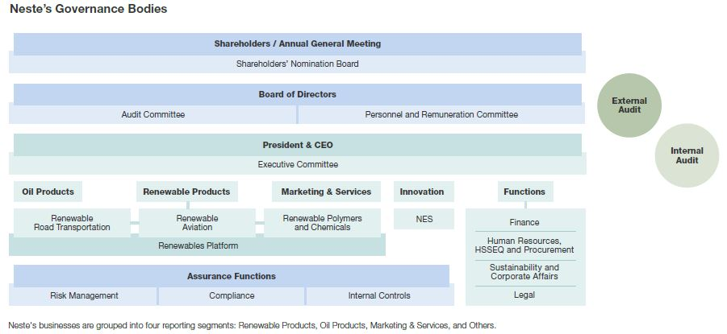

*Figure 1. Neste Governance Bodies (Neste, 2021).*

Neste’s headquarters are in Espoo, Finland. The control and management of Neste is split between the **Annual General Meeting of Shareholders** (AGM), the **Board of Directors**, and the **President and Chief Executive Officer** (President and CEO). The decision-making authority lies with shareholders at the AGM which appoints the members of the Board of Directors and the **Auditor**. Shareholders at the AGM make decisions on matters including the approval of the Financial Statements, the distribution of profits for the year (detailed in the balance sheet), discharging the members of the Board of Directors and the President and CEO from liabilities, and the election and remuneration of the Chair, the Vice Chair, and the members of the Bord of Directors and the Auditor. **Shareholders’ Nomination Board**, composed of 4 members (3 largest Company’s shareholders and the Chair of Board of Directors), is responsible for drafting and presenting proposals covering the remuneration and personal changes in Board of Directors. The Board of Director is responsible for Neste’s strategy and overseeing and monitoring the Company’s business and appointing the President and CEO. The President and CEO, assisted by the Executive Committee (ExCo), is responsible for managing the Company's business and implementing its strategic and operational targets.

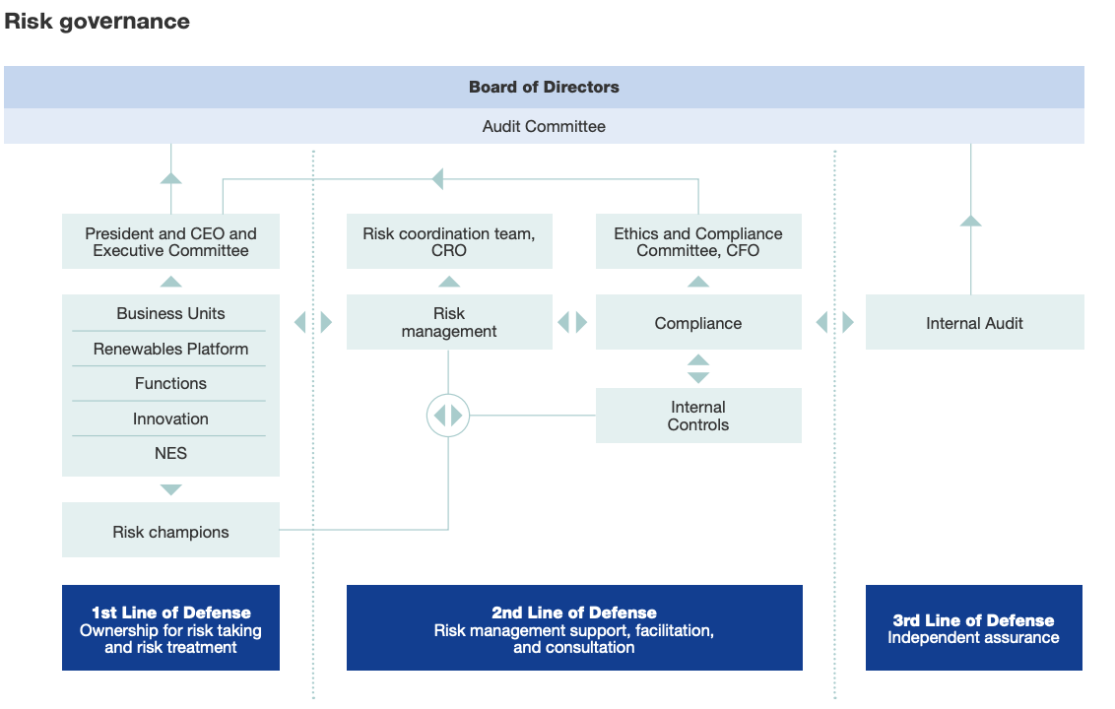

*Figure 2. Neste’s Risk Governance Table (Neste, 2021).*

When talking about the governance, it’s important to talk about the Risk Management and Governance. The **Neste Board of Directors** has the ultimate accountability for risk oversight. Among other duties the Board is in this role responsible for setting the Group’s risk appetite and for approving the Risk Management Policy. The practical implementation, development and monitoring of risk management processes is based on the three lines of Defense model (refer to the Risk Governance table). In 2020, special risk management initiatives focused on business continuity management practices, major investments and business model changes.

**Section 2**

***2.1. Business description***

Neste Oyj is a global producer of renewable and oil products, and the world’s largest producer of renewable diesel, headquartered in Espoo, Finland. The company was founded in 1948 with the mission to secure Finland’s oil supply and after the steady growth in the 1970s, it became Finland’s largest company. Also, the company became listed on the Helsinki Stock Exchange in 1995.

Over the years, the company has changed its strategy from a regional oil refiner to becoming a global leader in renewable and circular solutions. The current strategy has its roots in technological development in the 2000s, which accelerated the opening of new factories focusing on the renewable products in 2010 and 2011. The strategy consists of three priorities: scaling up faster and bolder renewable and circular solutions, increasing innovation and driving efficiency in operations. The vision for the future is to become a global leader in renewable and circular solutions.

The company has grouped its businesses into four segments: renewable products, oil products and marketing & services and others.

**Renewable products**’ refineries are located in Finland, the Netherlands and Singapore, producing approximately 3.2 million tons of renewable products annually. This segment can be further divided into three focus areas: renewable road transportation, renewable aviation and renewable polymers & chemicals. Together they form a renewables platform which further expands the company’s production capacity and raw material platform. From 2023 onwards, the planned capacity expansion in Singapore will increase the total renewable product capacity to 4.5 million tons per year. The main market areas for renewable products are Europe and North America, and the customer base includes retailers, wholesale customers, aviation industry, fleets, and polymers and chemicals producers.

Neste Oyj produces approximately 14 million tons of high-quality **oil products** per year to the Baltic Sea area, Europe and North America. Customers include retailers and distributors, oil majors and trading companies, petrochemicals companies as well as companies marketing lubricants and solvents.

The third segment, **marketing & services**, focuses on providing and developing sustainable solutions to meet the needs of customers, consumers and B2B partners. Main market areas include 749 stations in Finland and 215 stations in the Baltic countries and the customer base consists of consumers, transport service, customers in the aviation, shipping, industrial and agricultural sectors, municipalities, heating customers, and distributors.

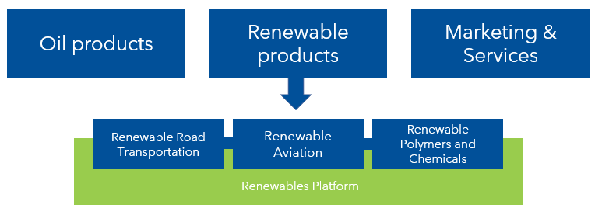

*Figure 3. Businesses of Neste Oyj grouped into segments.*

***2.2. Industry overview and competitive positioning***

Our industry overview and competitive positioning analysis will not contain a direct comparison with other companies. This is because over the past years Neste has been focusing mostly on renewable products and transforming their old business. All investments have mainly focused on their segment of renewable products. The renewable product segment is already now responsible for most of their profit and value; thus, we believe a comparison with other oil refinery companies is irrelevant in that respect. On the other hand, there is no other company operating in the same market regions as Neste with a similar volume regarding their renewable products segment.

Our industry overview and competitive positioning analysis will contain the following parts. First, we will elaborate the competitive position of their three market segments: Renewable products, Oil products, and Marketing & Services. Following that we will analyze the current markets in which Neste operates in through the Porter five forces model. Last, we will show investments of Neste’s competitors in renewable products and thereby demonstrate the possible changes in the competitive landscape in the future.

***2.3. The competitiveness of Neste’s market segments***

In the market segment of **renewable products** Neste has a strong competitive position holding around 40% of the global production capacity in renewable diesels. Their capacity makes Neste the biggest producer of diesel and sustainable aviation fuel globally. Currently Neste is producing annually 3,2 million tons of renewable products which is expected to increase to 4,5 million tons by 2023 through the expansions in capacity to their production facilities in Singapore. Also, the investment in a product facility in Rotterdam will be supporting their renewable product segment. Neste has also managed to establish themselves as a forerunner in chemical recycling of plastics and delivering renewable chemical solutions. Although Neste currently has a strong competitive position it acknowledges in their annual report the risk of new competition, current competitors developing their products and the change in customer preferences.

The profitability of Neste’s segment of **Oil products** has been decreasing through the years and in the fiscal year of 2020 the segment had a negative impact on the profit of Neste. Oil products and their profitability are highly dependent on the market development of crude oil and other external factors. During the past year the oil market has been highly volatile and Neste is expecting this trend to continue. Due to the interdependence of the oil refinery market these changes in the oil market impact their competition as much as it does impact Neste. Main competition in the oil product segment are other advanced refineries located in northwestern Europe, Russia and the Middle East.

The third segment of **Marketing & Services** entail their 964 gas stations located in Finland and the Baltic countries. Their 749 gas stations in Finland make Neste the largest gas retailer by market coverage. This segment has managed to hold their profitability of but is a relatively small part of their revenue stream. Main competitors are other large retailers in Finland and in the Baltics.

***2.4. Porter’s five forces model***

Figure 4. describes the level of competition in the market in which Neste Oyj operates through Porter’s five forces. The threat of new entrants grows when companies that are not currently in the fuel business start to produce biofuel or develop more advanced technology than what Neste Oyj currently has. Customers are a potential threat to the oil industry if their preferences rapidly change towards clean mobility, e.g. electric cars. Also, for example, oil price fluctuations and possible supply disruption risks can affect negatively profitability. The fifth force, the existing competition in the industry and competitors' ability to undercut the company, will be analyzed in the following section.

*Figure 4. Porter’s Five Forces model.*

***2.5. Future development of the competitive landscape - Renewable products***

Neste is a relatively small player in the global oil refinery business but has managed to maintain a strong competitive position in the renewable fuel business for years. As legislation and consumer preferences have been shifting towards renewable products it is only to expect that other companies will start the same transformation as Neste has been doing. During 2020 over 20 companies globally announced investments in renewable HVO diesel facilities (Greenea, 2021). In the European market the HVO production capacity is expected to increase from the current 3,5 million ton to 11,3 million ton annually (Greenea, 2021).

As demonstrated earlier the biodiesel market is currently heavily invested in and Neste can expect the competitive landscape to change within the next years. Below we will present some investments in renewable products planned by competition of Neste which are targeted to the same regions as Neste operates in.

**UPM** (Finland),is planning on an investment of a biofuel refinery with the capacity of 500 000 tons, the investment is currently in the planning phase (UPM, 2021). Currently UPM has a biofuel refinery with the production capacity of 130 000 tons located in Lappeenranta.

**Marathon Petroleum (USA)** is an American oil refinery company which is about to multiply their production capacity of Biodiesel by transforming an oil refinery to a biofuel refinery. The production is expected to start 2022 and reach full capacity in 2023 (Marshall Petroleum, 2021).

**Eni** (Italy), Italy’s largest oil company is planning to be fully decarbonized by 2050. Their goal is supported by investments in advanced biofuels. Currently having a production capacity in biofuels of 1,1 million tons and planning to double it by 2024. Eni has transformed their oil refinery in Venice and is amongst other investments currently expanding its capacity. (Eni, 2021).

**Preem** (Sweden), is currently repurposing their oil refinery in Lysekil for biofuels in addition to already having a biofuel refinery in Gothenburg. Their goal is to increase their production capacity of biofuels by 5 million tons by 2030. (Preem, 2021).

**Section 3**

**3. Financial analysis**

In this section, we will analyse the historical financial performance of Neste Oyj during the last three fiscal years 2019, 2018 and 2020.

***3.1. Income Statement***

In the Table 3.1 is presented the income statement of Neste for the fiscal year of 2020. The fiscal year of 2020 is put in comparison with the fiscal year of 2019 and 2018 and conducted a trend analysis.

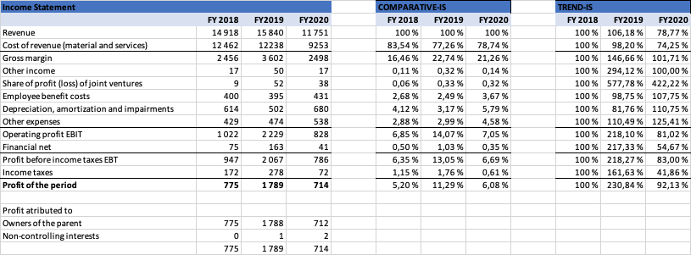

*Table 3.1. Income statement of Neste*

There has been a decrease in revenue in the fiscal year 2020 of around 4 billion EUR. The revenue of year 2020 was only around 74% of the revenue of 2019 and 79% of the revenue of 2018. This significant decrease is mostly due to the loss of revenue in the segment of oil products (see. Table 3.2). In their annual report Neste has explained that the significant decrease in the revenue of their Oil product category has been due both the decrease of demand and over supply of oil during the COVID-19 pandemic (Neste, 2021).

As Table 3.2. shows there has been a decrease of revenue generated from the Oil products of 4 353 billion EUR in comparison to the year 2019. As the Oil products still have a significant role in the revenue stream of Neste Oyj the renewable product category has increased its role and managed to have a growth in revenue.

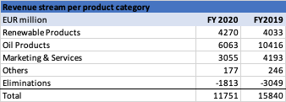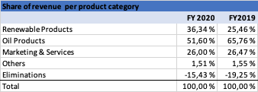

*3.2. Table revenue stream per product category. 3.3. Table Share of revenue per product category*

The most notable factor about the different product categories is their difference in the potential to generate operation profit. Which is illustrated in Table 3.4. As the renewable products were only around 36% of the total revenue of 2020 the product category contributed an operating profit which was 150% the operating profit of the whole company. Whereas the Oil product segment which was still 51% of the whole revenue had contributed a negative operating profit. Even in the year 2019 prior to the COVID-19 pandemic the Oil Products contributed only around 18% of the overall operating profit as Renewable products were responsible for 83%.

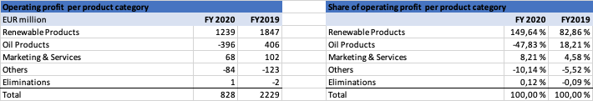

*Table 3.4. Operating profit per product category and share of operating profit.*

The operating profit margins of each product category are illustrated in Table 3.5. The operating profit has decreased over the period and in 2020 it was 7% as in 2019 it was 14%. The renewable products have in both fiscal years of 2020 and 2019 outperformed the operating profit margin of the whole company. Their operating profit has decreased but is still outperforming the overall profit margin.

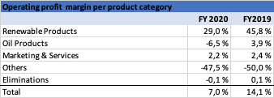

*Table 3.5. Operating profit margin per product category*

As a conclusion to our analysis of the balance sheet and specifically the revenue and profitability of the company over the period in question there are few important factors. We asses that the decrease in revenue produced by Oil products is mainly due to the COVID-19 pandemic we do not believe these to be permanent.

Neste is in an ongoing process of transforming their business towards renewable products supported by investments and acquisitions. To support the competitiveness of their oil product segment during 2020 Neste closed their refinery in Naantali and is planning to transform it over time towards renewable products (Neste, 2021). As demonstrated earlier the renewable products have a much higher profitability in comparison to the other products segments, thus we believe that by transforming their business and even more focusing on renewable products Neste will remain profitable even if the COVID-19 pandemic continues.

***3.2. Balance sheet***

The decrease in the revenue of Neste during 2020 has had little effect on their balance sheet. The balance sheet of Neste is demonstrated in Table 3.6. including the comparison of the fiscal years of 2020, 2019 and 2018.

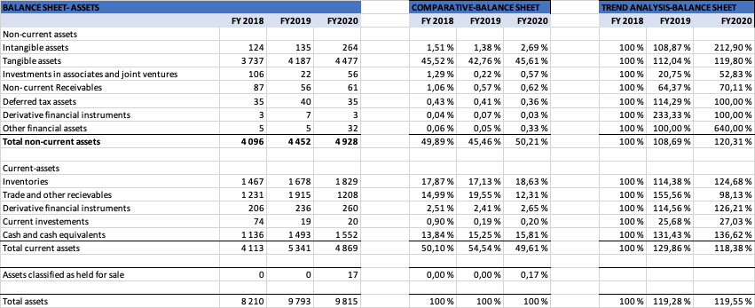

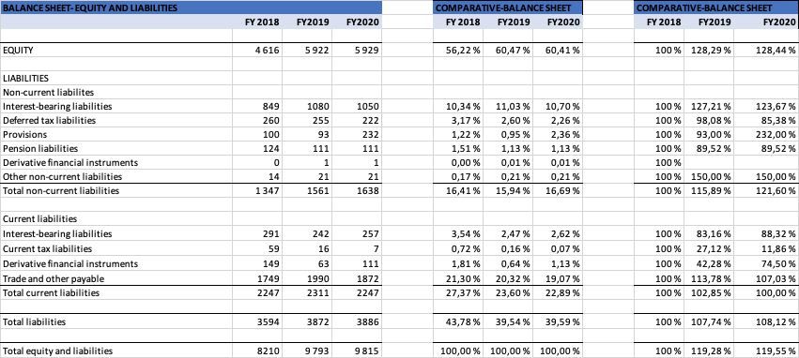

*3.6. Table Balance sheet of Neste*

In the assets of Neste there are some changes which need to be given some attention. First their Intangible assets were almost doubled during 2020, which was mostly due to increase in Goodwill. Goodwill increased during 2020 with 104 million EUR due to the acquisitions conducted during the year (Neste, 2021). The Inventories of Neste have been increasing over the period of question and at the end of 2020 they were 124% of the inventories at the end of 2018.

There was also a decrease in the trade and other receivables in comparison to 2019. The trade receivables were at the end of 2019 1,6 billion EUR and at the end of 2020 952 million EUR, this in our assessment is explained by same reasons as the decrease in revenue during 2020. The assets marked as classified for sale worth of 17 million EUR consists of their Neste and Futura vessels (14 million EUR) part of their Oil product segment and the sale of LPG cylinder business and stake in Innogas Oy (4 million EUR) a part of their Marketing & Services segment. The LPG cylinder business and stake in Innogas Oy were sold during January 2021 to Oy Linde Gas Ab. The vessels are planning to be sold during 2021.

Regarding the equity and liabilities of Neste it is important to note that their equity ratio for 2020 was little over 60%. Neste has increased their Provisions during 2020 by 140 million EUR. The increase in the provisions was mostly due to the closing of the Naantali refinery. Provisions were made for site demolition, clean-up and personnel arrangements in the amount of 139 million EUR. As looking at the balance sheet of Neste one important factor is their leverage ratio %. The leverage ratio of Neste has been constantly decreasing and at the end of 2020 it was only 4.7%. The leverage relation is one of Neste’s key financial targets (Neste, 2021).

***3.3. Cash flow statement***

Table 3.7 contains the cash flow statements of Neste Oyj for the past three years:

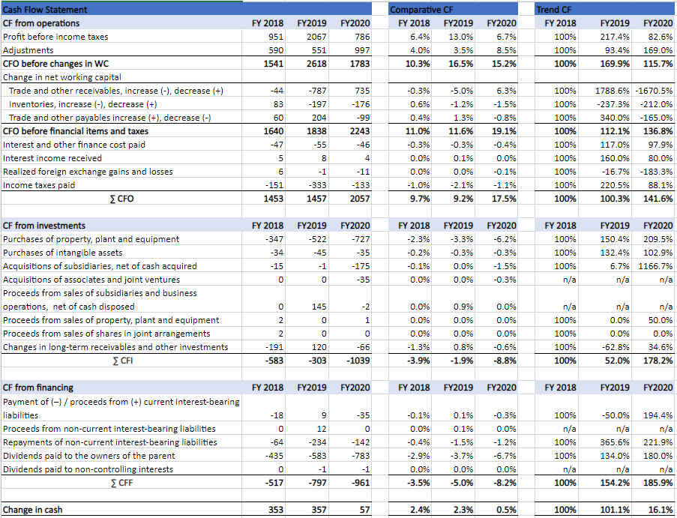*Table 3.7 the cash flow statements 2018-2020*

**Cash flow from operations**

Cash flow from operations in Neste Oyj is positive and it has increased from around 1453 million EUR to 2057 million EUR in a couple of years. Also, the cash flow from operations is on average slightly higher than operating profit?

**Cash flow from investments**

A notable change can be seen in purchases of property, plant and equipment, and acquisitions of subsidiaries. In recent years, Neste Oyj has started to invest more in renewable energy, with the aim of improving its long-term profitability. For example, they acquired Count Terminal in Rotterdam as well as Mahoney Environmental in North America in 2020 and closed their refining operations in Naantali in 2021 (Neste, 2020; Turun Sanomat, 2020).

**Cash flow from financing**

The amount of dividends paid has increased during three years. It is notable that because the year 2019 was successful, the company approved large dividends just before the corona crisis.

Overall, the net cash flow has been positive during the three-year period, slightly decreasing in 2020.

***3.4. Financial ratios and key figures***

Table 3.8 shows the key financial ratios 2016-2020:

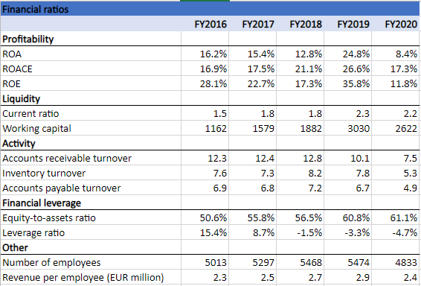

*Table 3.8 the key financial ratios 2016-2020*

Years 2015-2020 were selected for the analysis because the company changed its strategy towards renewable products in 2015. To summarise, the financial ratios presented in table 3.4 show that the financial performance of Neste Oyj is rather good. Profitability has increased especially in 2019 when ROE was remarkably higher than the industry average of 11% (Verizon Media, 2021). However, profitability experienced a rather large decline in 2020. Nevertheless, Neste Oyj has reached its financial targets in all these five years: ROACE has remained above 15% and leverage ratio below 40% (Neste, 2020). The probability of financial risk is low, and the current ratios indicate solid liquidity. Also, turnover ratios illustrate the efficient management of the company’s assets. The number of employees has been steadily growing until 2019 but decreased recently due to the changes in strategy.

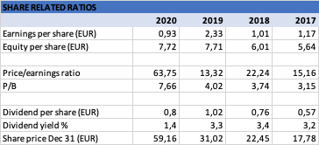

*Table 3.9 Share related ratios*

In Table 3.9 are demonstrated ratios related to the share of Neste. We have included years 2020, 2019, 2018 and 2017 to the Table. Years prior 2017 have excluded from the calculation since Neste conducted a stock split in 2019 and no restated figures to the year prior to 2017 were available.

The stock price at the end of 2020 was almost the double of the price at the end of 2019, respectively the P/E ratio has increased and was at the end of 2020 63,75. As a high P/E can be seen as a sign of an over valuated company we believe that for Neste it is not the case. In our assessment the high share price and P/E ratio are related to the high expectations of the market mostly due to Neste’s heavy investments in renewable energy and potential for future earnings.

Dividend per share has been reasonably consistent with over the period in question. Neste has the dividend policy of paying at least half of their earnings as dividend to the stockholders.

**Section 4**

***4.1. Investment risks***

*4.1.1. External risk*

* Economy and politics: The market is volatile, as geopolitical tensions and economic growth risk bring a considerable amount of uncertainty to the market. The operating business can be hugely affected by the sanctions on oil exports from Venezuela and Iran.
* Market: The demand for oil products is shrinking because of lockdowns around the world. Although the world is recovering, the pandemic still greatly impacts the customers' behavior. For example, the public may eliminate the frequency of business trips, because some meetings can be held online. Moreover, with the developing awareness of sustainability, the public is seeking more sustainable alternatives. As a result, the demand for products might be slightly decreased.
* Regulation: Government policies, regarding the low-carbon transition and carbon footprints, such as the regulation changes in carbon emission on EU and US, can bring pressure to Neste daily operation. The business is restricted by regulation from various dimensions.

*4.1.2. Strategy risk*

* Competitor threats: Threats may arise from changes in the competitive landscape. Current competitors develop the technologies for clean mobility change, the evolution might challenge Neste’s leading position in the competition.
* Quality management: Evolving customer requirements together with more complex sourcing and logistics networks and production methods increase the exposure to quality risks that need to be managed well to maintain the high-quality brand image.
* Recruitment: there is a risk that Neste may not be able to recruit and retain the highly skilled employees that are needed for strategy deployment and successful operations in the future.

*4.1.3. Business continuity risks*

* Property, plant and equipment: The fossil fuel refineries in Finland and the the renewable diesel refineries in Singapore and the Netherlands are exposed to disruptions in supply of utilities, machine breakdown. Vessels owned by Neste are subject to risks like maritime disaster, property damage.
* Demand shock: The pandemic has caused a global demand shock, increasing the uncertainty in the company level business continuity concern.

***4.2. Valuation***

Based on our assessment, we issue a SELL recommendation on Neste. As a result of COVID-19, we expect a stagnated growth outlook. Overall, we conducted two different valuation models, the Dividend Discount Model and Discounted Cash Flow model. Both results suggest that the current market price is overvalued.

*4.2.1. Discounted Free Cash Flow Model*

**Sales:** Based on the insights by Nordea, owing to a collapsed demand in COVID-19, the industry is now encountering a major shock and the oil industry will lose about 9% of annualized output in 2020-21 (Oil industry outlook: Be prepared for a peak before 2030, 2021). As the vaccination rate is growing, we assume that the company can slightly recover in the first year, with a close to 1% growth rate. We believe that the sales will grow gradually, yet it still needs to take about 4 years to reach the previous level.

*Figure 4.1 Sales forecasting*

**EBIT:** The EBIT will reach 9.5% from the current level of 7.1%. According to the annual report, Neste Oyj have updated their brand promise to “change runs on renewables”. They are currently having a transformation in providing sustainable solutions with 25% of the employees are working in Innovation and Technology. Thus, Neste is expected to increase their EBIT margin in the future.

Figure 4.2 EBIT forecasting

**CAPEX:**  As the company disclosed that they are going to make an important investment in 2021 to improve their internal management, it is expected that the capital expenditure will increase continuously in the following two years. However, for the year 2022, as the company didn’t disclose any investment activity in the annual report, we assume the change will not increase notably. Since the Singapore project is going to run in 2023, we assume that the capital investment will escalate greatly.

Figure 4.3 CAPEX forecasting

**WACC and Cost of equity:** Based on the company disclosed numbers, we can calculate the cost of equity and the weighted average cost of capital (WACC). WACC was used as a discounted factor in the DCF model, while the cost of equity was used in the DDM model.

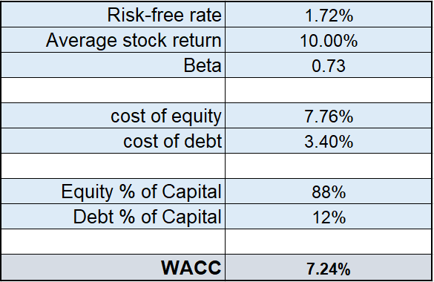

Table 4.4 WACC and cost of equity

**Sensitivity analysis**: Given the company performance and the historical data, our assumption for the terminal growth rate is about 1.5%. As a result, the current market price will be around 39.02.

However, the future is hard to predict, since no one can truly know how long it will take for the company to retrieve. Besides, it is impossible to calculate the true WACC. Therefore, a sensitivity analysis is applied to evaluate the market price with the change in the two most influential factors in our prediction, WACC and terminal growth rate. By comparing the current market price, which is 46.39 EUR, the numbers highlighted in orange are higher than the current market price.

*Table 4.5 Sensitivity analysis for FCF*

*4.2.2. Dividend Discount Model*

**Comparable net profits:** Based on our forecast, the comparable net profits = Comparable operating profits - total financial income and expense- income tax expenses - non-controlling interest - tax on items affecting comparability

*Figure 4.6 Comparable Net Profit Forecasting.*

**Dividends**: Historically, Neste Oyj distributed about 50% of its comparable net profit as dividends. Thus, based on our forecasts, the comparable net profit and dividend are calculated as shown below.

*Figure 4.7 Dividends Forecasting.*

**Discounted factor**: We used the cost of equity as the discounted factor in our dividend discount model, which is equal to 7.76%, as calculated above.

**Sensitivity analysis**: Similarly, the cost of equity and the terminal growth rate can vary depending on the actual situation. We highlight the scenarios when over the current market price.

*Table 4.8. Sensitivity analysis for DDM.*

*4.2.3. Valuation Conclusion*

By comparing two valuation results, the enterprise value ranges from 27723.72.91 to 29967.79 million euro. The fair market value should be between 35 to 40 euros. Thus, we suggest to sell the stocks with a target price of 37.5, based on our analysis.

Figure 4.10 valuation overview

Figure 4.9 Total enterprise value

**REFERENCES**

Eni. 2021. *Advanced biofuels to decarbonize transport.* https://www.eni.com/en-IT/operations/biorefineries.html

Greenea. 2021. *Horizon 2030.* https://www.greenea.com/wp-content/uploads/2021/01/Greenea-Horizon-2030-Which-investments-will-see-the-light-in-the-biofuel-industry-1.pdf

Marathon Petroleum. 2021. *Renewable Fuels.* https://www.marathonpetroleum.com/Operations/Renewable-Fuels/

Neste Oyj. 2021. *Neste Annual Report 2020.* https://www.neste.com/sites/neste.com/files/release_attachments/wkr0006.pdf

Neste Oyj. 2020. *Neste Annual Report 2019.* Retrieved from https://www.neste.com/for-media/material/annual-reports

Neste Oyj. 2019. *Neste Annual Report 2018.* Retrieved from https://www.neste.com/for-media/material/annual-reports

Neste Oyj. 2018. *Neste Annual Report 2017.* Retrieved from https://www.neste.com/for-media/material/annual-reports

Neste Oyj. 2017. *Neste Annual Report 2016.* Retrieved from https://www.neste.com/for-media/material/annual-reports

Neste. 2020. *Neste acquired Count Terminal Rotterdam to strengthen its growth strategy in renewable raw materials supply*. https://www.neste.com/releases-and-news/renewable-solutions/neste-acquired-count-terminal-rotterdam-strengthen-its-growth-strategy-renewable-raw-materials

Neste. 2020. *Neste ostaa Mahoney Environmentalin tukeakseen kasvustrategiaansa ja vahvistaakseen asemaansa uusiutuvien raaka-aineiden hankinnassa.* https://www.neste.com/fi/tiedotteet-ja-uutiset/circular-economy/neste-ostaa-mahoney-environmentalin-tukeakseen-kasvustrategiaansa-ja-vahvistaakseen-asemaansa

Neste. 2020. *Neste as an investment*. https://www.neste.com/investors/neste-investment

Neste. 2021. *Corporate Governance.* https://www.neste.com/investors/corporate-governance

Neste. 2021. *Neste Corporate Governance Statement.* https://www.neste.com/sites/neste.com/files/neste_corporate_governance_statement.pdf

Nordea. 2021. Oil industry outlook: Be prepared for a peak before 2030. [online] Available at: <https://insights.nordea.com/en/economics/oil-industry/> [Accessed 5 April 2021].

Preem. 2021. *Our collaborations on renewable fuels*. https://www.preem.com/in-english/investors/corral/renewable-fuel-projects/

Turun Sanomat. 2020. *Nesteen Naantalin jalostamon sulkeminen varmistui – Naantalista katoaa 230 työpaikkaa*. https://www.ts.fi/uutiset/talous/5150372/Nesteen+Naantalin+jalostamon+sulkeminen+varmistuiNaantalista+katoaa+230+tyopaikkaa

UPM. 2020. UPM etenee biopolttoaineiden kasvusuunnitelman seuraavaan vaiheeseen https://www.upm.com/fi/tietoa-meista/medialle/tiedotteet/2021/01/upm-etenee-biopolttoaineiden-kasvusuunnitelman-seuraavaan-vaiheeseen/

Verizon Media. 2021. *How Did Neste Oyj’s (HEL:NESTE) 21.07% ROE Fare Against The Industry?* https://finance.yahoo.com/news/neste-oyj-hel-neste-maintain-082734520.html